GHANA COCOA BOARD (COCOBOD)
COCOA HEALTH AND EXTENSION DIVISION
ASIWA DISTRICT

REPORT ON THE INAUGURAL CEREMONY OF COOPERATIVE COCOA FARMERS AND MARKETING UNION LTD AND LAUNCHING OF THE ASIWA COCOA DISTRICT.
- INTRODUCTION
This is a report on the Inaugural Ceremony of Cooperative Cocoa Farmers and Marketing Union Ltd and Launching of the Asiwa CHED District of COCOBOD.
The report gives account on preparation towards the programme, events that took place on grounds, acknowledgement and concluding statement.
- PREPARATION
Preparation towards the programme started around mid-January, 2020. It was spear headed by the Cooperative Officer of the Bosome-Freho district assembly. The programme was primarily to inaugurate the cooperatives within the political district. District executives were elected to champion the course with the help of the Cooperative Officer.
In October 2020, the newly created Asiwa district of CHED-COCOBOD began operation and therefore being stakeholders in the affairs of farmers, teamed up with the department of cooperatives and the elected executives of the farmers’ union to organize the programme.
Upon several meetings, it was agreed to host the programme at Asiwa (the district capital of the Bosome-Freho district assembly) on 24th November, 2020.
Publicity was done in almost all the communities within the district and beyond since the cocoa district spans beyond the Bosome-Freho district. The Community Extension Agents (CEAs) aided in the publicity of the programme using all communication channels i.e community information centers, group meetings, phone calls, home visits, farm vists etc. Vehicle arrangements were made to convey farmers from their respective communities to the programme.
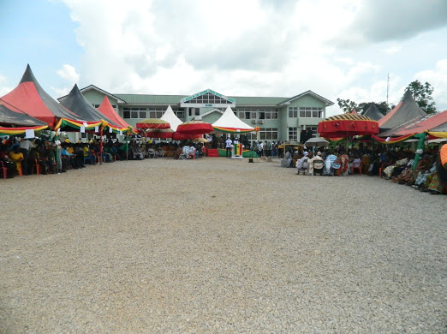
Durbar of the inaugural and launching ceremony

- PROCEEDINGS OF ACTIVITIES
Some farmers reported to the grounds around 7:30am and helped the committee and staff to arrange the grounds. This was followed by a float to demonstrate to the community the existence of the cooperatives in the district. The farmers in an appreciable number embarked on the exercise and returned around 10:00am. Mr. Emmanuel Quaisie (staff member) interacted with the farmers that were waiting behind on some Good Agricultural Practices (GAPs).
The representative of the chief of Kokofu, Barima Ofe Akwasi Okogyeasuo who was the chairperson of the ceremony arrived with other chiefs.

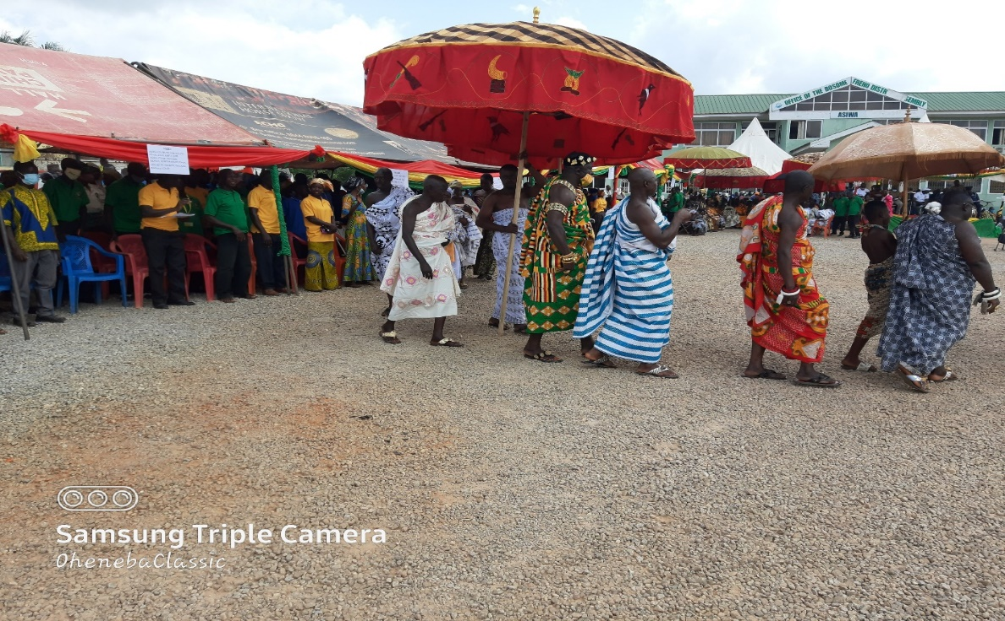
The representation of Nana Barima Ofe Akwasi Okogyeasuo arriving

Rev. Felix Agyei Cornelius (Assistant minister to the Asiwa district of the Presbyterian Church of Ghana, Freboye) said the opening prayer for the programme.

- INTRODUCTION OF CHAIRPERSON AND ACCEPTANCE SPEECH
Madam Sylvia Appiah (District Extension Coordinator) introduced the chairperson of the occasion and also introduced other dignitaries. The chairperson then gave his acceptance speech and also expressed his gratitude for hosting the capital of the new cocoa district on his land.
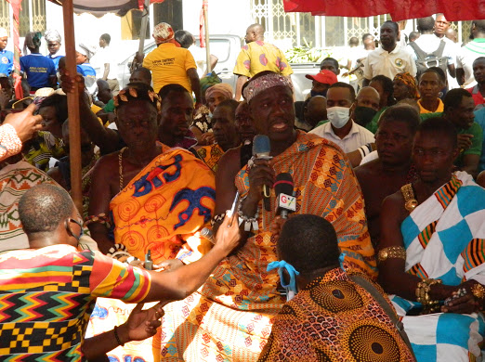
Nana giving his acceptance speech as a chairperson of the occasion

- WELCOME ADDRESS
The District Chief Executive of Bosome-Freho district, honourable Yaw Danso gave his welcome address. He appreciated the Chief Executive Officer of Ghana Cocoa Board, Hon. Boahen Aidoo and the entire management for successfully establishing a CHED district capital within the Bosome-Freho administrative district. He also used the opportunity to highlight some key interventions that his government through COCOBOD has been able come up with to ensure higher yield of cocoa and improve livelihood for cocoa farmers. Among some of these interventions he mentioned included the distribution of motorized pruners/slashers, pruning, subsidized cocoa fertilizers and cocoa hand pollination exercise.
The DCE acknowledged the thousands of jobs the cocoa hand pollination has created for the youth in the district. He again drew the attention of the participants of the measures his government has put in place to ensure that all farmers belonging to farmer cooperative received fertilizer to increase soil nutritional value to ensure a higher yield. The current increase in farm gate price of cocoa was not spared. He stated that his government is the government that has farmers at heart hence the massive increase in the producer price of cocoa.
He concluded by encouraging all participants to retain his government in power during the 2020 general elections so they could continue the good work they have started and that more is yet to come if they voted to retain them in power. He then welcomed all participants.
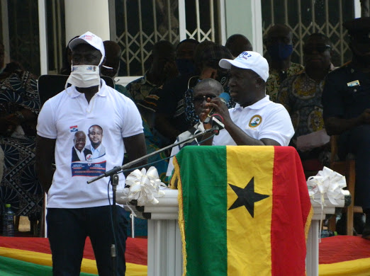
Hon. Yaw Danso (DCE of Bosome-Freho district) giving his welcome address

- KEY NOTE ADDRESS
The Executive Director of Cocoa Health and Extension Division (CHED) Dr. Emmanuel Nii Tackie Otoo who was the special guest of honour of the occasion gave his address and highlighted on some key intervention by Ghana Cocoa Board to ensure yield increase and ensure a better living condition of cocoa farmers. Among these interventions included the operation ‘prune all cocoa farms’. He commended the farmers for adopting and executing more than expected of them and so he was optimistic that there would be increase in the yield of cocoa. He also made mention of the pollination exercise, indicating that all these interventions are meant to increase yield and as a result, the enhanced livelihood of cocoa farmers.
He ceased the opportunity to inform participants on some new programmes that the Board was about to roll out. These programmes included the Cocoa Management System (CMS) and the Cocoa Pension Scheme. He encouraged all farmers to partake in the programme when they are finally rolled out. He concluded by asking farmers to access the new cocoa district office each time the need be and the officers will duly attend to them.
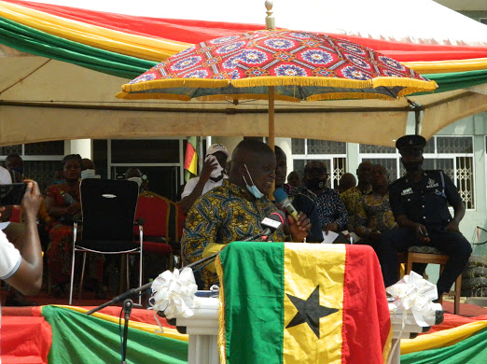
Dr. Emmanuel Nii Tackie Otoo (Executive Director of Cocoa Health and Extension Division CHED) giving his key note address

- ADDRESS AND PRESENTATION OF CERTIFICATES TO COOPERATIVES
The regional director of Department of Cooperative, Mr. Richmond Mensah also gave his speech and encouraged farmers to be active in their respective groups. He then told the participants about the importance of forming and belonging in cooperatives to aid their cocoa business. He then presented certificates to all the fifty-six (56) registered cocoa farmer cooperatives within the Bosom-Freho district assembly.
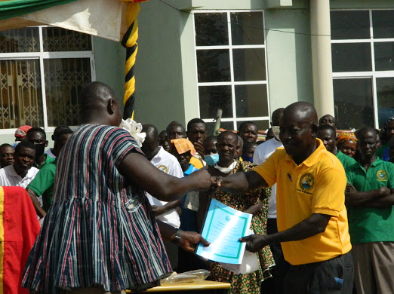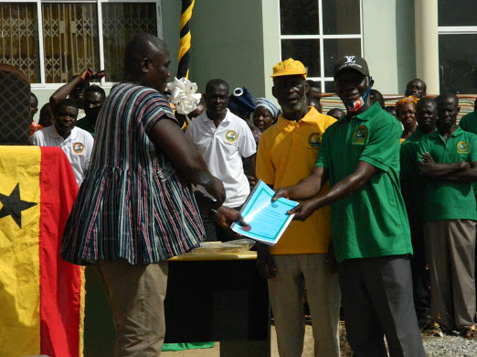
Some farmers receiving their certificate and by-law of the cooperative from Mr. Richmond Mensah, The regional director of Department of Cooperative.

- HEALTH SCREENING
The organizers made arrangement with the Bosome-Freho Health Directorate to undertake health screening for the farmers that may attend the programme. About five nurses we deployed to that effect and they conducted sugar level test, HIV test and checked the blood pressure of their clients. At the end, one hundred and sixty-eight (168) people were attended to. Two people tested positive for HIV and some people had higher sugar level than the normal as well as High blood pressure. All these people were counselled and referred to the appropriate unit of the health center to be attended to.

- CLOSURE
The chairman of the occasion gave his closing remarks and the vote of thanks was said by Madam Jennifer Boamah (District Extension Coordinator of Brofoyedru CHED district). Rev. Felix Agyei Cornelius gave the closing prayer and the programme was brought to closure around 3:30 pm.
Participants were refreshed and they departed.

- ACKNOWLEDGEMENT
The organizers acknowledge the efforts of all persons that helped in diverse ways in making the programme a success especially the Executive Director of Cocoa Health and Extension Division, Dr. Emmanuel Nii Tackie Otoo, the District Chief Executive of Bosome-Freho, Hon. Yaw Danso and the Asiwa District Cocoa Officer of CHED-COCOBOD Kofi Gyamfi Marfo and his able staff. Gratitude goes to the district and regional officers of the department of cooperative and the District Cocoa Officer and the District Extension Coordinator of Brofoyedru cocoa district who came to support. The Bosome-Freho District Health Directorate is also appreciated.
- CONCLUSION/REMARKS
The programme was successful and nothing bad occurred during and after the programme.

PREPARED BY APPROVED BY
SIGNED SIGNED
RAPHAEL BAAFI (CEA) KOFI GYAMFI MARFO
(DISTRICT COCOA OFFICER)

