REPORT ON CHILD HEALTH PROMOTION WEEK CELEBRATION FROM 10TH-14TH MAY 2021

INTRODUCTION
Child health promotion is celebrated to remind caretakers and the general population about our role and responsibility to ensure a better living state and growth of our children especially ensuring that they celebrate their fifth birthday. This exercise was carried out by the District Health Directorate in collaboration with the Environmental health department in all the public health facilities and outreach points despite the ongoing Covid -19 pandemic
OBJECTIVES
- To intensify awareness among the general public about routine child health services
- To sensitize community members against the spread of covid 19
- To assess the environmental friendliness and conduciveness to feeding and human habitation
- To mop up and reach all the unreached children under 5
- To search for priority diseases such as; AFP, Measles, Yellow Fever, etc
THEME
The theme for the child health promotion week is, “Promoting newborn and child health services in the wake of the covid 19 pandemic.”
PARTICIPANT
Health staff, Stakeholders, pregnant mothers, Nursing mothers, Caregivers, Chiefs, opinion leaders, Children under 5, etc

MINIMUM PACKAGE SERVICE RENDERED
- Growth monitoring
- Immunization
- Birth registration
- Vitamin A supplementation
- Nutrition counseling
- Assessmentnt of food vendors in schools
- Assessment of school feeding foods provision to children
- Promoting the use of ITNS
- Promoting ANC/PNC, for mother and newborn.
- Breastfeeding
- Prevention of covid 19

TEAM SUPERVISORS

NAME OF STAFF | RANK | CONTACT
JUSTICE OWUSU PRINCE | DNO | 0242537824
RITA KYEI | DHPO | 0548053528
LINDA BOAMPONG | DIST. ENV. HEALTH | 0544516145

KEY MESSAGES DISCUSSED

- Pregnant women should continue to attend Antenatal clinics to stay healthy and deliver healthily
- Pregnant women should avoid handshakes, hugs, and large gatherings to prevent infection.
- All pregnant women should regularly wash their hands with soap under running water or use an alcohol-based hand rub.
- If you have covid 19 wear a face mask to cover your nose and mouth to prevent the spread of the disease
- Always cover your baby well to keep him/her warm
- Start breastfeeding within 30mins after birth whether you are confirmed with covid 19 or not.
- Give your child only breast milk from birth to 6 months in other to boost their immunity to fight infections.
- Apply nothing except chlorhexidine to the baby’s cord until it falls off and the wound is healed.
- Stay at home and do not allow visitors to your home to prevent the spread of covid 19.
- Educating the general public on priority disease conditions such as AFP, Measles, Yellow fever, CSM, Covid -19, etc., and any unusual state of health.

KEY OBSERVATIONS
- Birth certificate registration was not done for most of the children coming for CWC
- Vitamin supplementation was low judging from the registered review
- Growth monitoring charts not done in the child records book
- Adherence to COVID-19 protocols was weak among food vendors
CONSTRAINTS
- No iodized salt kit to test for iodine in the salts used to prepare meals for children in schools
- Means of transport for the team were a challenge
- Some mothers do not wear a face mask for protection.
RECOMMENDATIONS
- Provision of iodized salt test kit by the district assembly to support the child health promotion exercise
- Frequent supervision of food vendors especially in school feeding areas.
- Continual observations of all protocols for COVID-19
CONCLUSION
The child health promotion week celebration provided support to some of the weak areas of service delivery and also identified certain areas that need collaborative support in improving the health of children under five years in the district.
SOME PICTURES OF CHILDREN’S HEALTH PROMOTION WEEK
ACTION PLAN FOR CHILD HEALTH PROMOTION WEEK
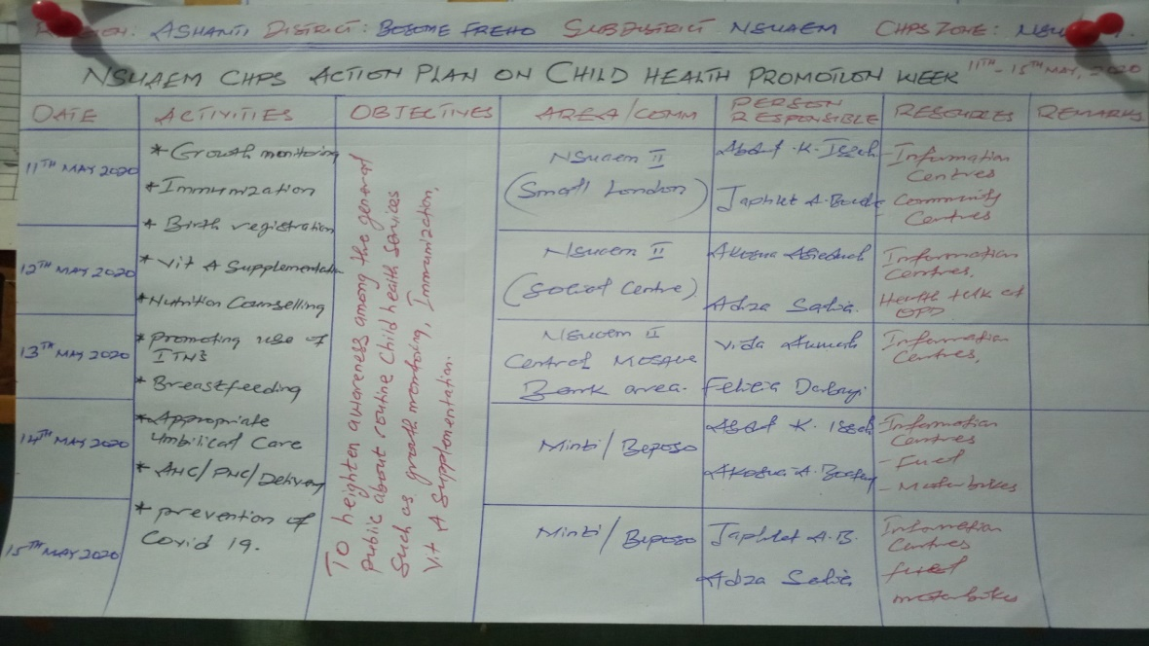

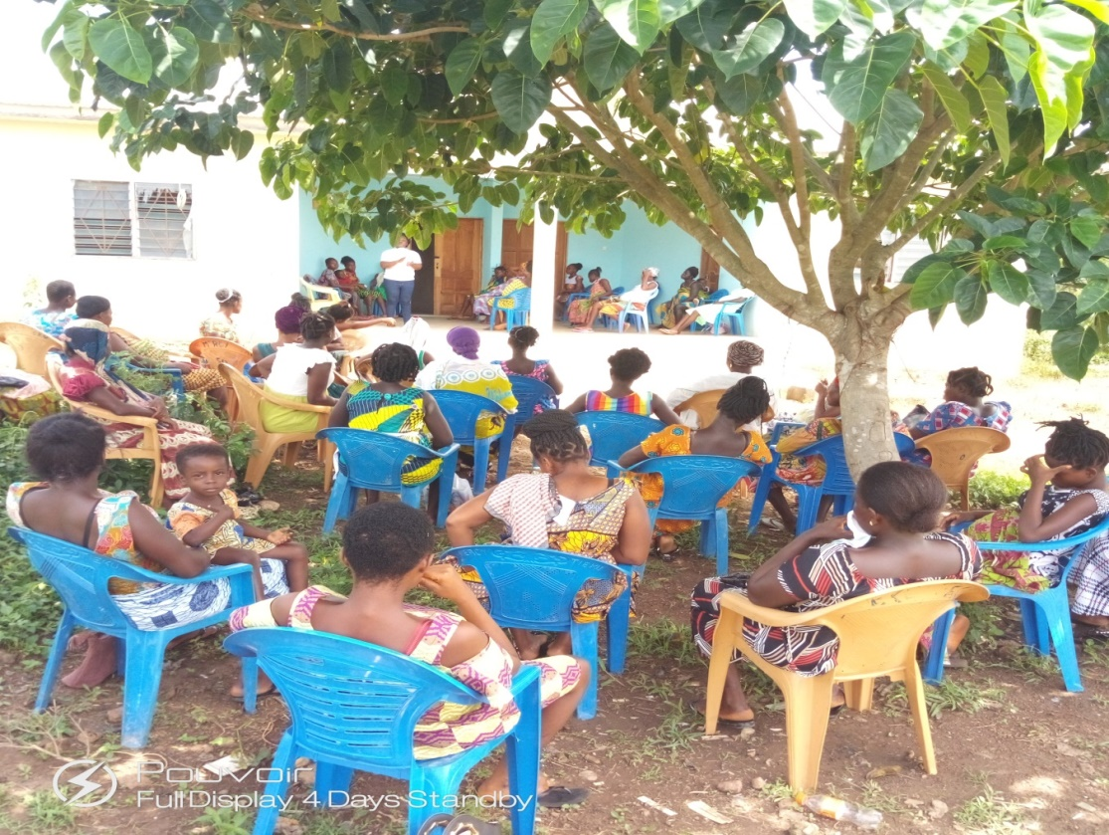
PROMOTING ANC/PNC SERVICE ON CHILD HEALTH PROMOTION WEEK

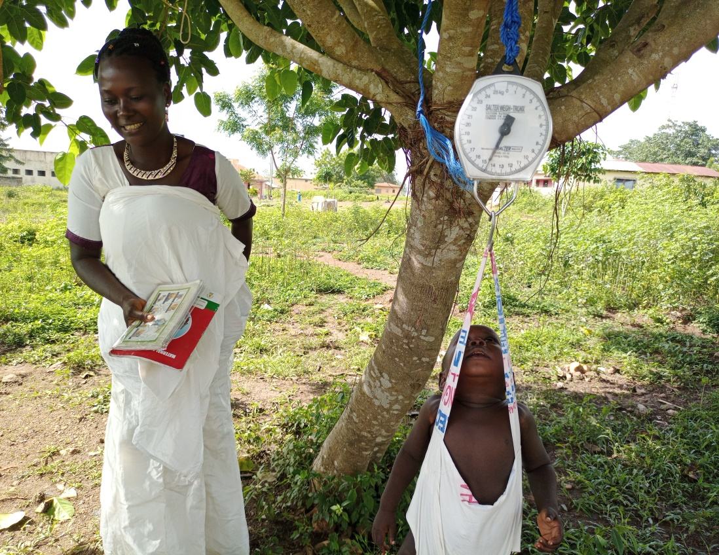
PROMOTING GROWTH MONITORING ON CHPW

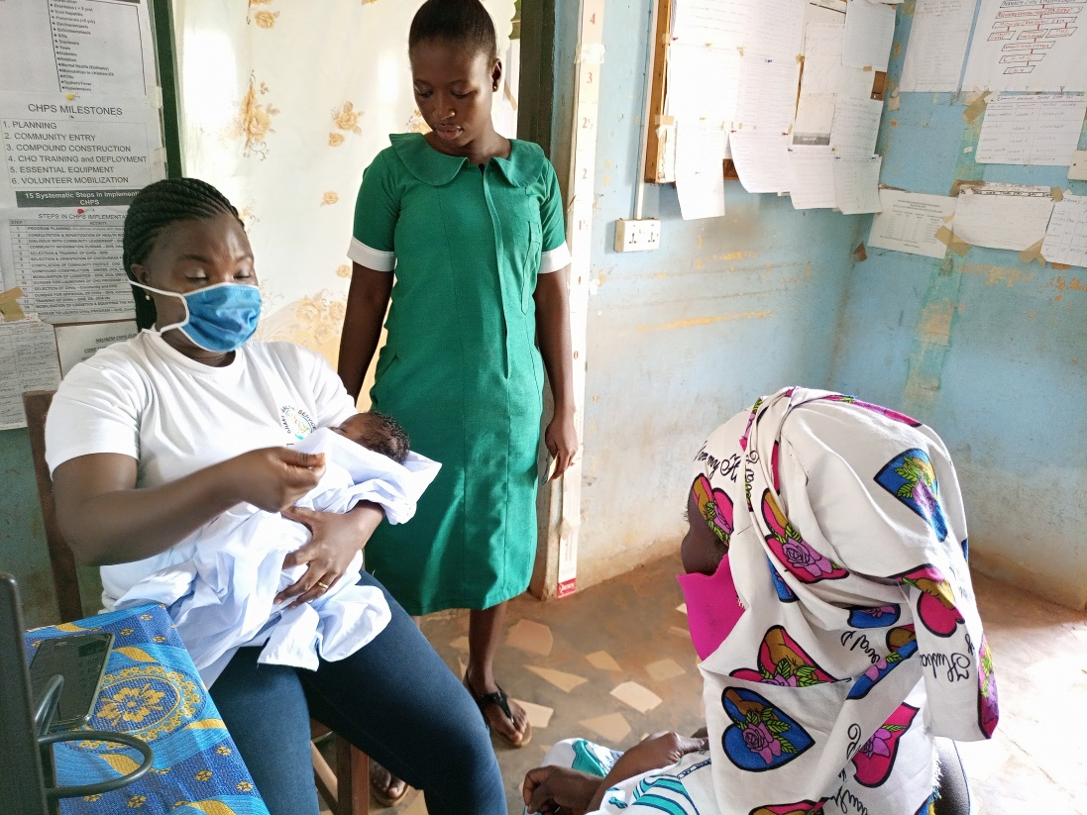
PROMOTING BREASTFEEDING DURING CHILD HEALTH PROMOTION WEEK
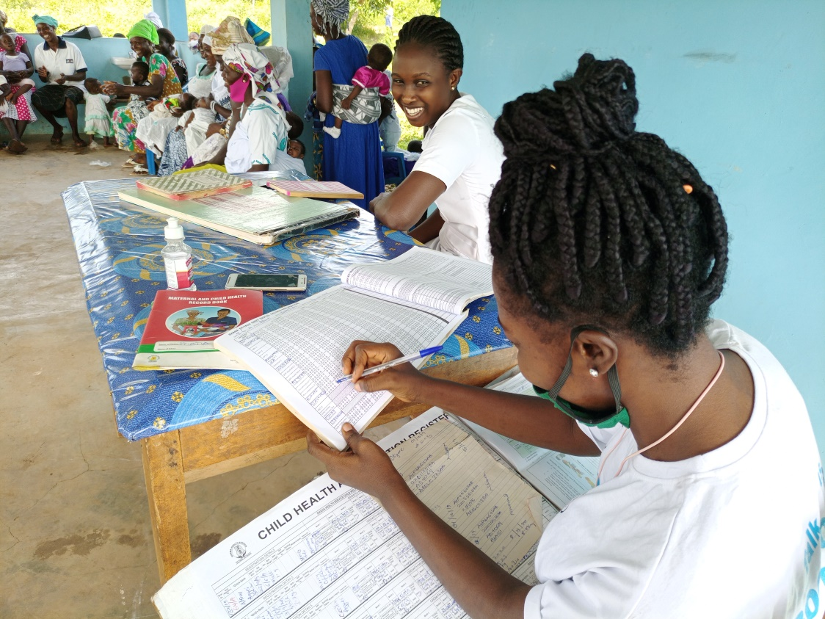
REGISTRATION OF CHILDREN ON CHILD HEALTH PROMOTION WEEK

